**CONTINUOUS INTEGRATION/CONTINUOUS DEPLOYMENT in AZURE DEVOPS**

URL From AZURE IS https://gmatch.azurewebsites.net

**CONTINYOUS INTEGRATION**

The pipeline name is webservice-game.my-app

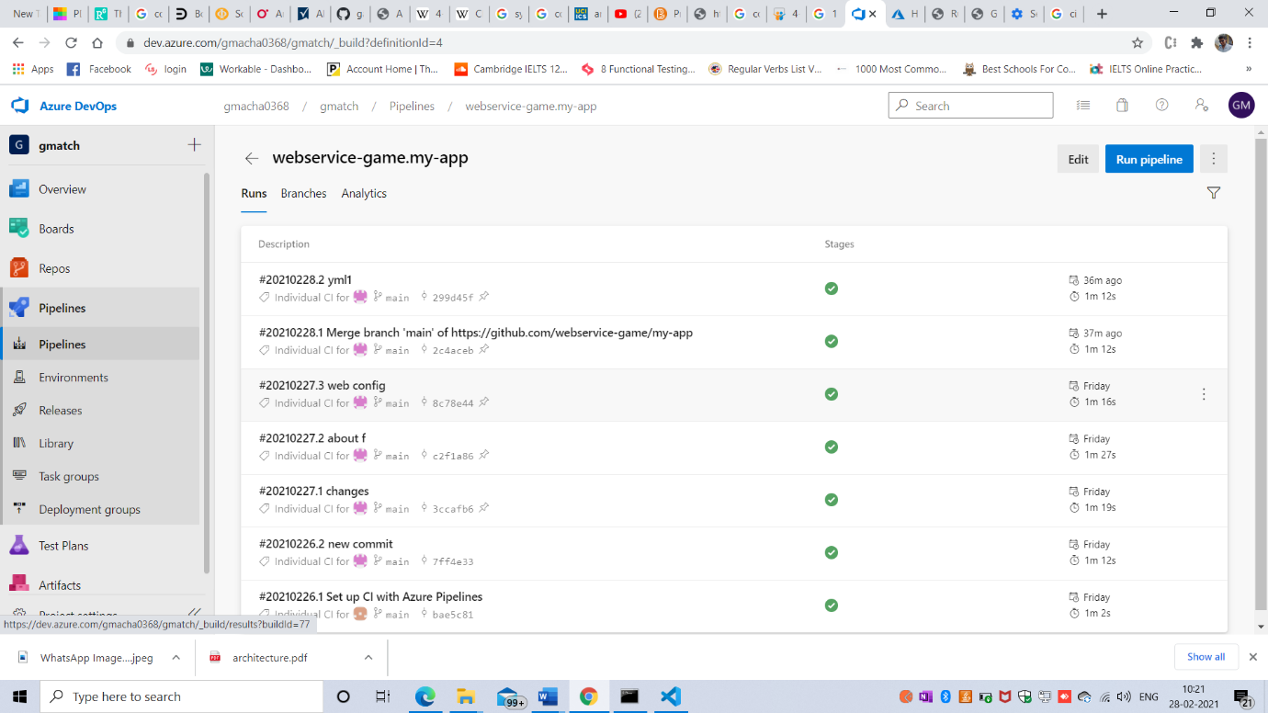

Success Screenshot

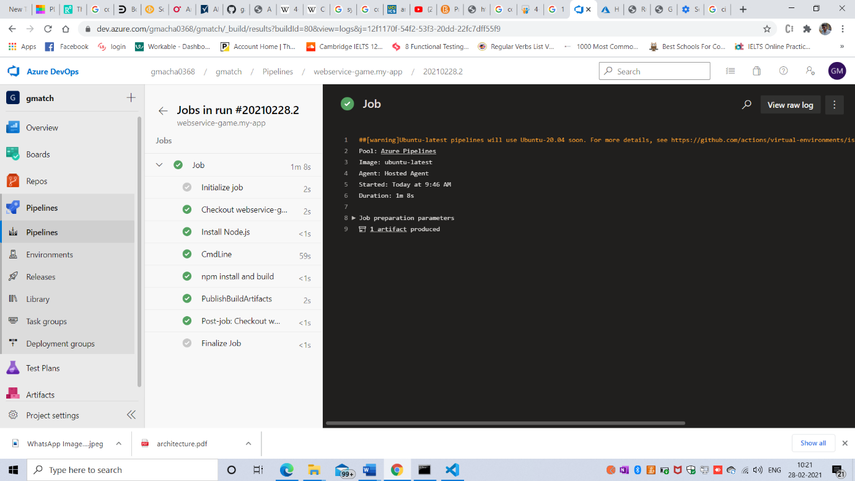

**CONTINUOUS DEPLOYMENT**

Automatically when someone push the code it will deploy.

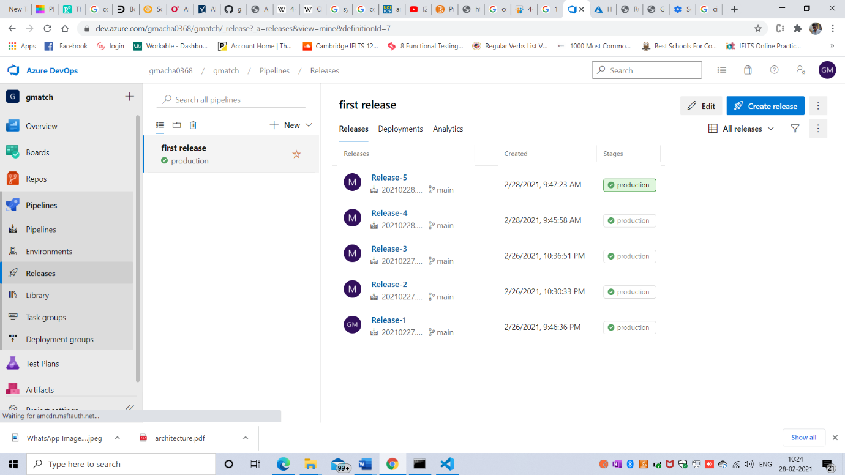

Successful deployment to the production

